**ClearView: Advance Image enhancement for Hazy and Foggy Conditions**

A Project Report submitted in partial fulfillment of the requirements for the award of the degree of

**Bachelor of Technology**

### in

**Computer Science and Engineering/ Electronics and Communication Engineering**

by

### Aakarsh Srivastawa(112115001)

### Abhikrant Rajesh Dhepe(112115005)

### Ankit Maurya(112115021)

### Anuja Deepak Kamble(112116005)

**Under the Supervision of: Dr. Nitesh Bharadwaj**

### Semester: V



#### Department of Computer Science and Engineering & Department of Electronics and Communication Engineering

#### 

#### Indian Institute of Information Technology, Pune

**(An Institute of National Importance by an Act of Parliament)**

#### November 2023

**BONAFIDE CERTIFICATE**

This is to certify that the project report entitled **“**ClearView: Advance Image enhancement for Hazy and Foggy Conditions**”** submitted by **Aakarsh Srivastawa** bearing the **MIS No 112115001**, **Abhikrant Rajesh Dhepe** bearing the **MIS No 112115005**, **Ankit Maurya** bearing the **MIS No 112115021** ,**Anuja Deepak Kamble** bearing the **MIS No 112116005** in completion of his/her project work under the guidance of **Dr. Nitesh Bharadwaj** is accepted for the project report submission in partial fulfillment of the requirements for the award of the degree of **Bachelor of Technology** in the **Department of Computer Science and Engineering and Electronics and Communication Engineering**, Indian Institute of Information Technology, Pune (IIIT Pune), during the academic year **2022-23**.

#### Dr. Nitesh Bharadwaj Dr. Sanjeev Sharma

Project Guide Head of the Department

Assistant Professor Assistant Professor

Department of CSE Department of CSE

IIIT Pune IIIT Pune

#### Dr. Shushant Kumar

Head of the Department

Assistant Professor Department of ECE

IIIT Pune

Project Viva-voce held on 06-11-2023

**Undertaking for Plagiarism**

We **Aakarsh Srivastawa, Abhikrant Rajesh Dhepe, Ankit Maurya, Anuja Deepak Kamble**  solemnly declare that research work presented in the **report** titled ClearView: Advance Image enhancement for Hazy and Foggy Conditions**”** is solely **our** research work with no significant contribution from any other person. Small help wherever taken has been duly acknowledged and that complete report has been written by **us**. I understand the zero tolerance policy of **Indian Institute of Information Technology Pune** towards plagiarism. Therefore **we** declare that no portion of my **report** has been plagiarized and any material used as reference is properly referred/cited. I undertake that if I am found guilty of any formal plagiarism in the above titled thesis even after award of the degree, the Institute reserves the rights to withdraw/revoke my **B.Tech** degree.

**Students’/ Student’s Name and Signature with Date**

**Conflict of Interest**

**Manuscript title: Clearview: Advance Image enhancement for Hazy and Foggy Conditions**

The authors whose names are listed immediately below certify that they have NO affiliations with or involvement in any organization or entity with any financial interest (such as honoraria; educational grants; participation in speakers’ bureaus; membership, employment, consultancies, stock ownership, or other equity interest; and expert testimony or patent-licensing arrangements), or non-financial interest (such as personal or professional relationships, affiliations, knowledge or beliefs) in the subject matter or materials discussed in this manuscript.

**Students’/ Student’s Name and Signature with Date**

## ACKNOWLEDGEMENT

This project would not have been possible without the help and cooperation of many. I would like to thank the people who helped me directly and indirectly in the completion of this project work.

First and foremost, I would like to express my gratitude to our honorable Director, **Prof. O.G. Kakde**, for providing his kind support in various aspects. I would like to express my gratitude to my project guide **Dr. Nitesh Bharadwaj**, **Department of CSE**, for providing excellent guidance, encouragement, inspiration, constant and timely support throughout this **B.Tech Project**. I would like to express my gratitude to the **Head of Department Dr. Sanjeev Sharma**, **Department of CSE, Head of Department Dr. Sushant Kumar, Department of ECE**, for providing his kind support in various aspects. I would also like to thank all the faculty members in the **Department of CSE/ECE** and my classmates for their steadfast and strong support and engagement with this project.



ClearView: Advance Image enhancement for Hazy and Foggy Conditions

## Abstract

Foggy and hazy conditions can have a detrimental impact on image quality for various applications. These atmospheric conditions scatter and disperse light, leading to reduced visibility and clarity. In scenarios like surveillance cameras or outdoor security systems, these conditions can obscure objects and details, making it difficult to discern critical information. Fog and haze can impede accurate data collection, affecting the quality of environmental observations and analyses. Overall, these conditions hinder the effectiveness of various imaging systems by diminishing clarity and visibility.

The project aims to explore effective techniques for enhancing images captured in diverse weather conditions to facilitate easier object detection. It will delve into the application of classification models like ResNet50 and image enhancement methods such as DCP (Dark Channel Prior) and Retinex. These approaches, when combined, can substantially improve image quality.

**Keywords:** Image Enhancement, haze, DCP.

## TABLE OF CONTENTS

**Abstract i**

**(i)** **List of Figures/Symbols/Nomenclature iv**

**(ii)** **List of Tables v**

1. **Introduction 1**

1.1 Overview of work . . . . . . . . . . . . . . . . . . . . . . . . . . . . . . . . . . 1

1.2 Motivation of work . . . . . . . . . . . . . . . . . . . . . . . . . . . . . . . . . 1

1.3 Literature Review . . . . . . . . . . . . . . . . . . . . . . . . . . . . . . . . . . 1

1.4 Research Gap. . . . . . . . . . . . . . . . . . . . . . . . . . . . . . . . . . . . . 1

1. **Problem Statement**

2.1 Research Objectives . . . . . . . . . . . . . . . . . . . . . . . . . . . . . . . . . 1

2.2 Methodology of work . . . . . . . . . . . . . . . . . . . . . . . . . . . . . . . . . 1

1. **Analysis And Design 5**
2. **Results and Discussion 9**
3. **Conclusion and Future Scope 10**

**6 References**

**7 Publication (if any)**

# List of Figures / Symbols/ Nomenclature

# Fig 1. Atmospheric Scattering Model for Dehazing Algorithm

Fig 2. Haze Imaging Model

Fig 3. Output After classification of Image

Fig 4(a) Input Hazy Image

Fig 4(b) Outpur Hazy Image

**Chapter 1**

**Introduction**

## Overview of Work

In the current fast-paced technological landscape, the combination of deep learning and image enhancement techniques has introduced a groundbreaking solution to a persistent issue: the differentiation and improvement of foggy and hazy images. This application holds significant importance, as it tackles a fundamental challenge encountered in various image-based systems and its potential to bring about transformative changes across diverse sectors, all with the common goal of enhancing image clarity in challenging conditions.

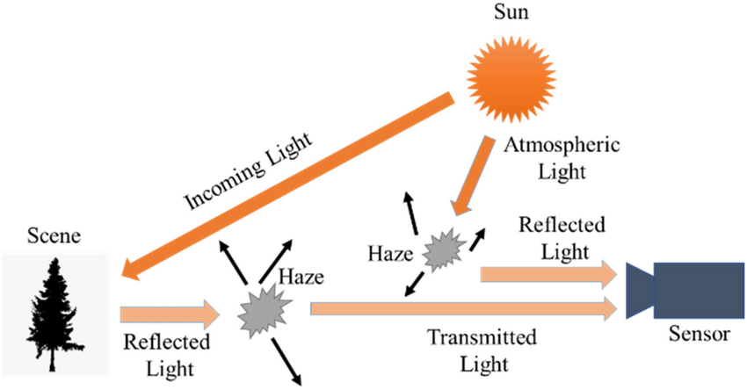

Fig 1. Atmospheric Scattering Model for Dehazing Algorithm

**1.2 Motivation of the Work**

The project's motivation arises from the pressing need to address a widespread challenge in our modern, technology-driven world. In various applications, especially those relying on visual data, issues related to fog and haze have become increasingly prevalent. These atmospheric conditions often obstruct critical visual information, which can have far-reaching implications on safety, efficiency, and decision-making in numerous sectors.

In sectors like surveillance and environmental monitoring, where accurate and timely information is crucial, these weather-related challenges can severely hamper the effectiveness of these systems. For instance, in surveillance, obscured vision can lead to critical security breaches, while in environmental monitoring, it can limit the early detection of environmental hazards. Accurate number plate detection is essential for various applications, including law enforcement and toll collection. Fog and haze can undermine the accuracy of number plate recognition systems, making it difficult to read plates clearly. This can have consequences for law enforcement efforts, toll collection efficiency, and even locating stolen vehicles.

The main goal is to improve the efficiency of various operations, whether in surveillance, environmental monitoring, or transportation. Additionally, it will increase data precision, ensuring that decision-makers have accurate and timely information at their fingertips.

ClearView: Advance Image enhancement for Hazy Conditions

**1.3 Literature Review**

Image dehazing has drawn much attention in the last decade. To overcome the ill-posed nature of the dehazing problem, early solutions have built on multiple images obtained in different atmospheric conditions. Alternatively, Cozma n and Krotkov and Nayar and Narasimhan recover the visibility of hazy scenes by employing side atmospheric cues that facilitate image depth estimation. Other approaches rely on the registration of geometric models to get access to image depth. Hardware based solutions have also been considered, such as the ones based on polarization filters, which captures multiple images of the same scene with different degree of polarization (DOP) and compare them to estimate the haze properties.

More recently, single image dehazing involves extensive research attention since it does not require special setup or side information, and is thus suitable even for challenging situations such as dynamic scenes. Early attempts at image dehazing have incorporated several images of the same scene, taken at different bad weather conditions [20], or using different polarization filters [21]. Kopf et al. [22] later performed dehazing of outdoor images by utilizing existing geo-referenced terrain and urban models including depth, texture and GIS data.

In the field of image dehazing and computer vision, several notable approaches have been developed to address the challenge of hazy or degraded images. Tan *et al*. introduced a technique that leverages a Markov Random Field (MRF) framework to remove haze by maximizing local contrast within image patches. Fattal *et al*. tackled the ambiguity between scene albedo and airlight by utilizing the lack of correlation between transmission and shading in localized pixel sets. Tarel *et al*. presented an efficient method for calculating the 'atmospheric veil' using edge-preserving linear filters, contributing to faster and more effective haze removal. Nishino et al. took a different approach, emphasizing the statistical independence between scene albedo and depth and leveraging this information within an MRF-based energy function rewrite. These papers collectively represent significant strides in image dehazing and computer vision, offering various techniques to enhance image quality and extract meaningful information from hazy scenes.

He et al. introduced the Dark Channel Prior (DCP), a widely adopted method for image dehazing. They observed that in clear images, the darkest pixel in an image patch tends to be close to zero, except in sky regions. Leveraging this insight and assuming that the transmission map within a small image patch remains constant, they devised a straightforward approach for generating a coarse transmission map. To refine the de-hazed image, He et al. proposed a computationally intensive soft matting operation to smooth out the transmission map and reconstruct the final dehazed image. Subsequent research efforts have sought to enhance both the quality and efficiency of the DCP method. Notably, in [8], authors introduced a general boundary constraint for the transmission map, with DCP being a special case of this more comprehensive framework.

Several color-based priors have been suggested as well for boosting dehazing performance . Fattal used the “color-lines” assumption, stating that pixels in small image patches have a one-dimensional distribution in RGB-space . The offset of these straight lines from the origin in hazy images allow us to estimate the transmission map. Berman et al. proposed a global approach, called non-local dehazing (NLD) . They observed that a haze-free image contains only several hundreds of distinct colors, clustered as points in RGB-space. In the presence of haze, these color clusters form a “haze-line” where the position of a certain pixel along the line corresponds to its initial radiance color and distance from the camera.

A Color Attenuation Prior (CAP) is also suggested, mixing hand-crafted observations with a data-driven approach. CAP assumes that the image depth, the amount of haze and the difference between the brightness and saturation are linearly correlated. To find the exact correlation, the authors opt for supervised regression between synthesized hazy patches and their corresponding depth maps. This results in fast inference at test time.

In the recent Gated Fusion Network (GFN), the dehazed image is generated by fusing multiple image components derived from the hazy input, including white balance, contrast enhancement, and gamma correction images. The network produces three confidence maps that determine the influence of each component. To mitigate the halo effects often associated with single-scale encoder-decoder structures, GFN employs a multi-scale architecture. It first generates a coarse output, which is then integrated as input into a finer-scale network. While this approach yields impressive results, it quadruples the size of the input during both training and testing, which can be inefficient in terms of memory usage. Furthermore, in a recent study, researchers harnessed a pre-trained VGG network as an encoder and focused on training a symmetric decoder using a combination of Mean Squared Error and perceptual loss, which offers an alternative approach to image dehazing.

In the domain of dehazing algorithms, a significant challenge hampering further progress is the difficulty in accurately assessing the performance of such algorithms, primarily due to the absence of reference haze-free images (ground-truth). The key obstacle in obtaining pairs of hazy and haze-free ground-truth images stems from the requirement to capture both images under identical scene illumination conditions. Consequently, most dehazing quality metrics are limited to non-reference image quality metrics (NRIQA). For instance, some methods rely on assessing the gradient of visible edges or utilize subjective evaluations of enhanced and original images captured in adverse visibility conditions. The Fog Aware Density Evaluator (FADE) predicts the visibility of hazy or foggy scenes from a single image without the need for corresponding ground-truth. Regrettably, in real-life scenarios where reference (haze-free) images are often unavailable, none of these approaches has gained widespread acceptance within the dehazing community. An alternative assessment approach involves the use of synthesized hazy images, where the optical model and known depth information are employed to replicate the haze effect. Notable examples include the FRIDA dataset for Advanced Driver Assistance Systems (ADAS), featuring computer-generated road scenes, and a dataset containing over 1400 real complex scenes derived from the Middlebury2 and NYU-Depth V2 datasets, offering high-quality real-world scenes with associated depth information. A notable approach to overcome the challenge of the absence of ground-truth haze-free images involves creating synthesized hazy images using Koschmieder's light propagation model, with a dataset extended to include outdoor hazy images. Additionally, a small dataset introduced in [27] includes four sets of indoor images with both hazy and RGB and NIR ground-truth, providing valuable data for evaluation. J.E. Khoury et al. [22] introduced the CHIC (Color Hazy Image for Comparison) database, offering hazy and haze-free images in real scenes captured under controlled illumination conditions, although it covers only two indoor scenes and lacks diversity in textures and scene depth. In a bid to further this progress, our paper introduces a novel dataset intended to serve as a more comprehensive benchmark for assessing dehazing algorithms in outdoor scenes, featuring ground-truth images. The O-HAZE dataset encompasses 45 diverse outdoor scenes captured under controlled lighting, making it a valuable resource for evaluating dehazing methods, and it is employed in the NTIRE dehazing challenge

**1.4 Research Gap**

While prior-based methods reveal fine image details, they often suffer from increased saturation and contrast, unrealistic colors and difficulty in handling sky regions. This is due in part to assumptions not suited for all hazy image patches. In addition, each image requires a separate non-trivial optimization and solution which can be prohibitive for real-time applications.

Learning based methods achieve impressive results, they are trained in a supervised way, relying on a synthetic dataset.Some methods use more accurate indoor depth information to create labeled inputs. This practice, however, directs increasing research effort to optimizing indoor performance, while the predominant need for dehazing is actually outdoors. Other methods use realworld outdoor images, but compromise the accuracy of the depth information.

Despite the impressive effort in designing dehazing algorithms, a major issue preventing further developments is related to the impossibility to reliably assess the dehazing performance of a given algorithm, due to the absence of reference haze-free images (ground-truth). A key problem in collecting pairs of hazy and haze-free ground-truth images lies in the need to capture both images with identical scene illumination.



# Chapter 2

# Problem Statement

In our technology-dependent world, persistent challenges arise from the adverse impact of fog and haze on the quality of visual data. These atmospheric conditions significantly obscure critical information, thereby hampering decision-making and safety in various sectors, including surveillance, environmental monitoring, and transportation. Inclement weather conditions, such as fog and haze, obscure vital details, leading to compromised road safety, delayed accident detection, and reduced accuracy in number plate recognition systems. This project aims to harness the power of deep learning and image enhancement techniques to differentiate between fog and haze and elevate image quality. The central issue to be addressed is the need to overcome the limitations imposed by fog and haze, ensuring the functionality of systems in challenging conditions and promoting safety, efficiency, and data precision in diverse domains.

**2.1. Research Objectives**

Create an image enhancement system capable of effectively operating in severe weather conditions like haze and fog. This system should significantly improve the visibility and quality of images captured in challenging environments. Address the issue of prolonged processing times associated with existing image enhancement techniques. The primary objective is to substantially accelerate the image enhancement process, making it more efficient and suitable for real-time applications. Improve the accuracy like for example number plate recognition under adverse weather conditions, such as fog and haze. This enhancement will be pivotal in supporting law enforcement efforts, traffic management, and toll collection systems by ensuring reliable and precise number plate identification. Create a system with a scalable architecture that can be tailored to accommodate a broad spectrum of applications.

**2.2. Methodology of the Work**

**Image Classification**

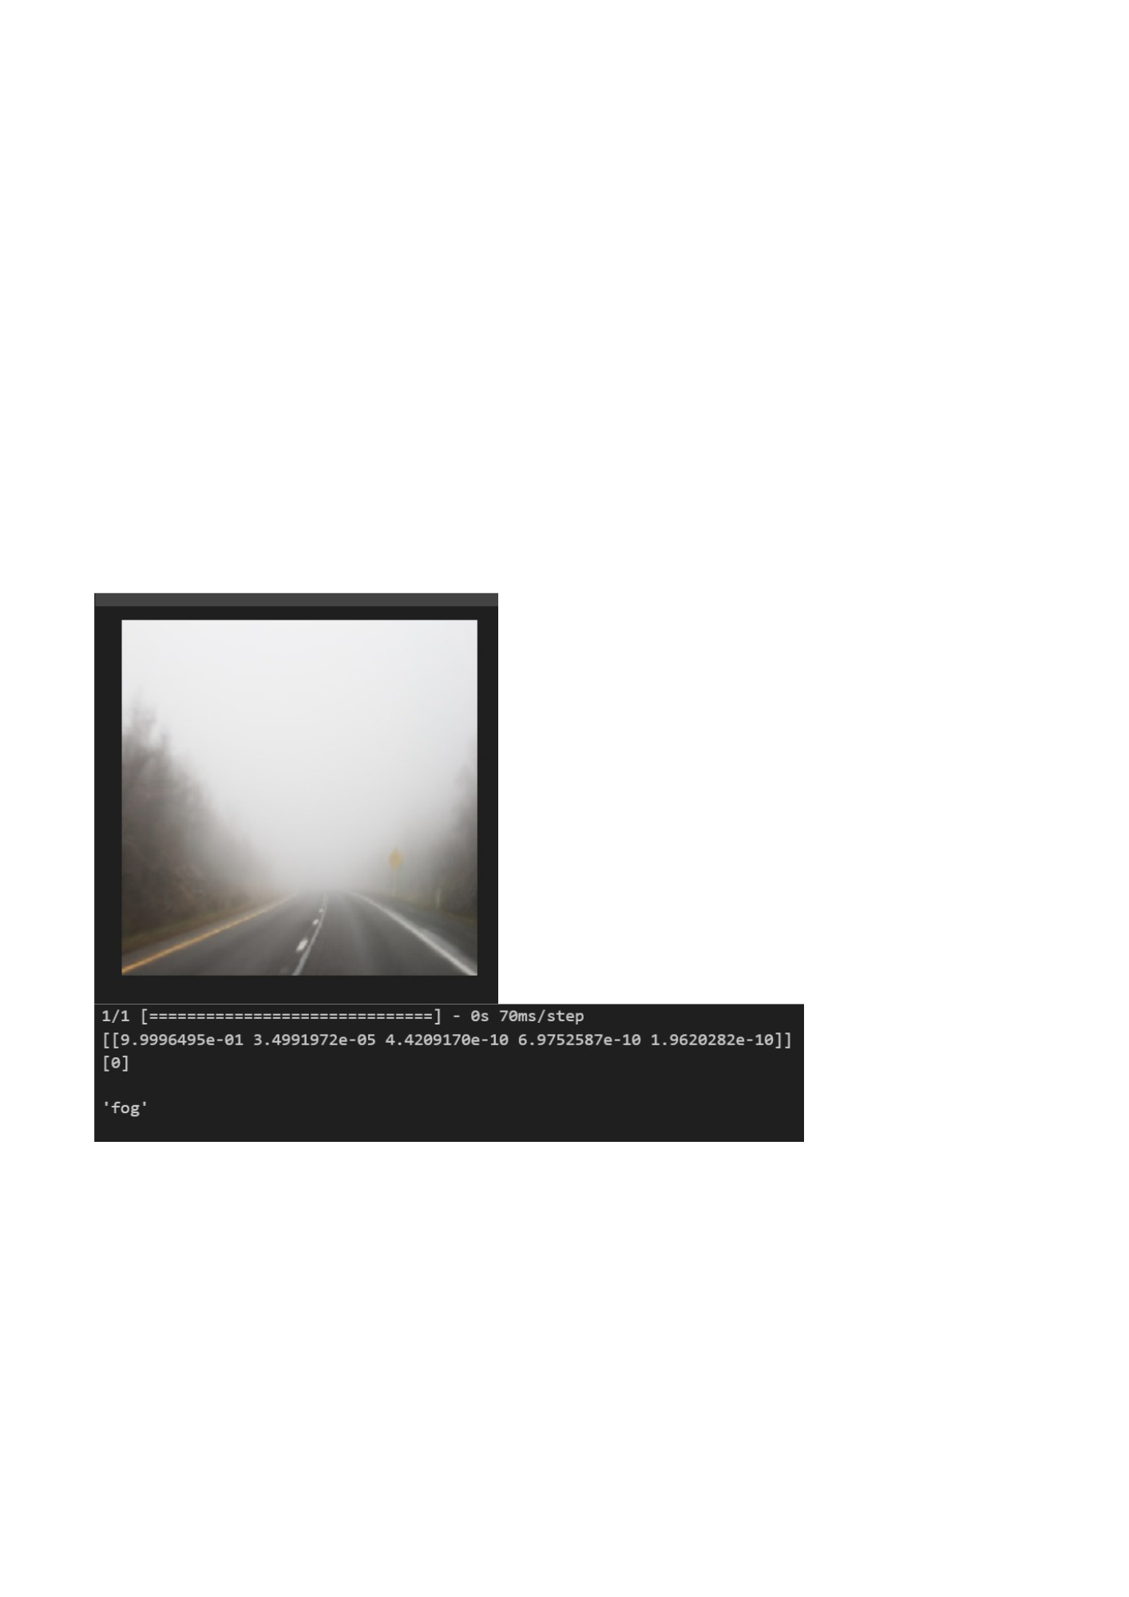ResNet-50, short for Residual Network with 50 layers, stands out as a remarkable deep convolutional neural network architecture, celebrated for its prowess in image classification tasks. This network's depth, comprising 50 weight layers that include convolutional layers, batch normalization, and fully connected layers, is a defining feature. What truly distinguishes ResNet is its ingenious use of residual connections, which elegantly addresses the vanishing gradient problem that plagues very deep networks. This innovation equips ResNet with a unique capability, making it exceptionally well-suited for tasks requiring intricate and fine-grained image classification. In our project, we took a systematic approach to maximize the effectiveness of ResNet-50. This involved curating a diverse dataset representative of the target scenarios, standardizing image properties by resizing them to the model's input size and normalizing pixel values. Data augmentation further enhanced the model's generalization. We thoughtfully partitioned the dataset into training, validation, and testing sets, adjusting ratios as needed for robust model development. By initializing ResNet-50 with pre-trained ImageNet weights, we harnessed the wealth of features from a broader dataset, setting the stage for improved model performance. Our project also entailed customization, training, and validation of ResNet-50 for the specific classification task at hand. Careful fine-tuning of hyperparameters was performed to optimize model performance. Ultimately, we assessed the model's proficiency on a separate test dataset, using key metrics to measure its classification accuracy and overall effectiveness. This comprehensive approach ensured that ResNet-50 was leveraged to its fullest potential in our image classification endeavour.

Fig 3 Output after classification of Image

The popular haze formation model in [8] is given as:

(1)

(2)

Where I(x) is observed intensity, *J* is scene radiance, A is global atmospheric light, and t is the medium transmission describing the portion of the light that is not scattered and reaches the camera.The first term *J(x)t(x)* is called direct attenuation part and second term *A(1-t(x))* is called airlight.

As per above equation, the observed hazy image, I(x) , is a convex linear combination of haze-free scene radiance , and the atmospheric light component A which is represented as 3 constant vector in RGB space, A=(Ar ,Ag,Ab).To control relative force of each component, in each pixel of image transmission map coefficient is used. The transmission is a function of depth , *d(x)* of the scene from the observer. Our goal in single image dehazing is to obtain the free scene radiance *L(x).* To do so, however one needs to solve a set of 3N equations (only I(x) is given), with 4N+3 unknowns (J(x),t(x),A). Thus , addition prior knowledge of images is needed **.**

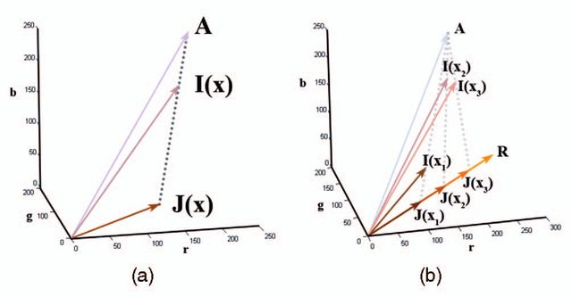

Fig 2. Haze Imaging Model

**Dark Channel Prior**

DCP is based on the following observation made on haze-free outdoor images: in maximum non-sky patches, at least one pixel has a low color channel intensity, meaning that the minimum light intensity in these areas is extremely small. The dark channel prior principle allows for the following expression of the formula:

dark(c) (3)

Where,

C=One of three color channels of pixel L.

𝜴(x)- Square area with X as center.

According to the dark channel prior theory, in extremely dark images, the presence of darkness causes some pixels to appear brighter, as though even darker pixels are more affected by this increase in brightness. However, in a foggy image, the areas that are illuminated by the fog can reveal the presence of fog.

Thus, we can compute fog density and light penetration through the fog using dark channel prior theory and fog reflection data. This can extract depth information from the scene and produce a clear, high-resolution image free of fog.

**4. Haze Removal Using DCP**

There are 4 steps in the defogging algorithm based on dark channel prior: the estimation of transmittance, the optimization of transmittance, the estimation of atmospheric light, and restoration of foggy images.

4.1 Estimation of Transmittance

First of all, we will assume that the Atmospheric Light **A** is given. We further assume that the transmission in local patch 𝜴(x) is constant and patch transmission as . Normalizing eq (4) we get

(4)

Applying dark channel prior to it () we get:

(5)

Now we take min operation among the three-color channel on the above equation and obtain

(6)

According to the dark channel prior, the dark channel of haze free radiance tends to zero

(7)

Since Ac is always positive which means

(8)

Putting Equation () in Equation () we get

(9)

As per observation we can see that DCP is not good for sky region but the colour of sky in a hazy image I is very similar to atmospheric light A.

(10)

Eq(12)  gives which is true because sky is at infinite and tends to zero transmission.

As we can see in daily lives, even in clear days the atmosphere is not completely free of any particle. So have still exist when we see distant image and also as per aerial perspective, the presence of haze is a fundamental cue for human to perceive depth. [ ] Suppose if we remove haze thoroughly, the image may seem unnatural and also depth may be last. So, for distant object in order to optimally keep small haze we used constant parameterinto equation.

(11)

The value of is application based it vary accordingly to application. Since transmission map calculated using DCP has some halos and artifacts so to resolve this issue we apply soft matting.

**Soft matting:**

The haze information model is very similar to the composition model in image matting where output image is convex linear combination of foreground and background images which is controlled by matte. A transmission map is exactly an map. Therefore, we apply soft matting algorithm to refine the transmission.

So we denote transmission map by Rewriting andin vector form as and we get cost function as.

(12)

Where,

Laplacian matrix proposed by Lavin.

Regularisation parameter.

The first term of equation is called as smooth term whereas second term is called as data term.

The Laplacian matrix can be given by,

(13)

(14)

Where i,j are two pixel within a small patch around pixel n | size of patch equal to 3X3=9, andare mean and covariance of patch.

identity matrix and is smooth parameter equals to 10-6.

**Estimating the atmospheric light**

In most of the single Image methods, the atmospheric light A is estimated from mostly haze opaque when weather is overcast, and sunlight can be affectively ignored for example- pixel with highest intensity is used as atmospheric light in [ ] and is further refined in [ ].

So as per the above case the only source of light is atmospheric light so scene radiance of each color channel can be represented as

. (15)

Where <=1 is reflectance of scene point. The haze imaging point can be rewritten as

. (16)

But in practical case, we can’t ignore the effect of sunlight so now equation becomes

(17)

So, from above equation we conclude, brightest image pixel can be brighter than atmospheric light. So, this is the problem and its solution is that using Dark Channel method for finding most haze opaque region in image and then select top 0.1% brightest pixel in dark channel for improved estimation of atmospheric light.

**Recovering the Scene Radiance**

With the use of transmission, we can recover the scene radiance using the eq-1.

But the direct attenuation term can tends to 0 when tends to 0. the directly recovered scene radiance is prone to noise, therefore we restrict the transmission to lower bound which means a small amount of haze are present in very dense haze region, therefore final scene radiance is is recovered by

(18)

We increase the exposure in the final recovered image since the haze free image has lower scene radiance .

# Chapter 3

# Analysis and Design

We evaluate the performance of our model on given dataset. There test sets are created synthetically, therefore it contains both clean images and their hazy version. The parameters which we used for quantitative analysis are Peak Signal to Noise ratio (PSNR) and structural similarity Index Measure (SSIM).

PSNR is most commonly used parameter for analysis of Image quality in image processing area. It is ratio of max possible power of image and power of corrupting noise that affects quality of its represented. It is calculated in terms of decibel unit.

Mathematically it is represented as,

(22)

Where

*L -* represents the dynamic range of the image.

*MSE* - stands for the Mean Square Error.

In our case, PSNR value is 12.0041.

SSIM is perceptual metric that quantifies image quality degradation caused by processing such as data compression or by losses in data transmission. SSIM basically compares two images based on luminosity, contrast and structure. It is calculated using following equation

(23)

Where,

*L-* luminous intensity relies on the average values of *I1 and I2.*

C-contrast depends on the variance of *I1 and I2..*

S-structure takes into consideration both the variance and covariance of *I1 and I2..*

In our case SSIM value is 0.6663

# Chapter 4

# Results and Discussion

The project successfully developed a real-time analysis system for the detection of smoke and haze in various scenarios. This capability enables our first responders and heroes to assess situations more effectively, enhancing their decision-making and safety in emergency situations. Through the project's efforts, an image enhancement system was created, allowing for clearer views even in the presence of smoke and haze. This enhancement empowers individuals to obtain better visual information in challenging conditions, improving situational awareness and overall safety. The project accomplished the implementation of object recognition techniques, enabling the identification of key objects and individuals within video feeds. This capability greatly enhances the efficiency and effectiveness of video analysis in applications such as surveillance, security, and emergency response.

In our evaluation process, we are assessing the performance of our model on a dataset that comprises both pristine (clean) images and their corresponding hazy versions, which are synthetically created. To gauge the quality of your model's outputs, you have employed two key quantitative metrics: Peak Signal-to-Noise Ratio (PSNR) and Structural Similarity Index Measure (SSIM).

**Peak Signal-to-Noise Ratio (PSNR)**

PSNR is a widely-used parameter for analyzing image quality in the field of image processing. It quantifies the quality of an image by comparing the maximum possible signal power to the power of the noise that negatively impacts its representation. The PSNR is expressed in decibel units, and its mathematical representation is as follows:

*L -* represents the dynamic range of the image.

*MSE* - stands for the Mean Square Error.

In our specific case, the PSNR value is 12.0041, which serves as a measure of image quality in terms of the signal-to-noise ratio.

**Structural Similarity Index Measure (SSIM)**

SSIM is a perceptual metric employed to quantify the degradation in image quality caused by processes like data compression or losses during data transmission. It assesses the similarity between two images based on three main components: luminosity, contrast, and structure.

The SSIM calculation is presented as follows:

*L-* luminous intensity relies on the average values of *I1 and I2.*

C-contrast depends on the variance of *I1 and I2..*

S-structure takes into consideration both the variance and covariance of *I1 and I2..*

In our specific case, the SSIM value is 0.6663, which reflects the structural similarity between the hazy and clean versions of the images. A higher SSIM value typically indicates a higher level of quality and similarity between the two images.

Both PSNR and SSIM are essential metrics for evaluating image quality, with PSNR focusing more on pixel-level differences and SSIM accounting for perceptual aspects like luminance, contrast, and structural similarity. The choice of which metric to prioritize depends on the specific goals and requirements of your project.

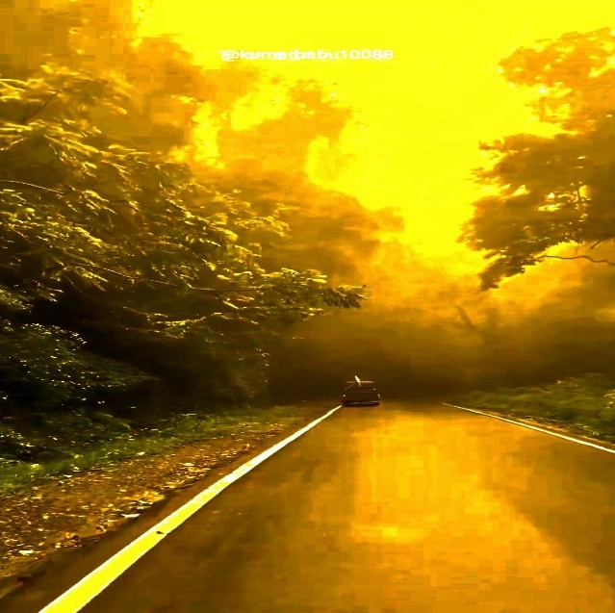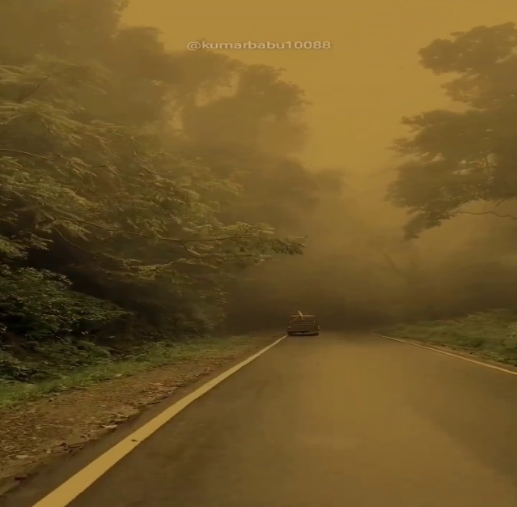

Fig 4(b) Output Iimage

Fig 4(a) Input hazy Image

# Chapter 5

# Conclusion and Future Scope

In our project, we've achieved a significant milestone by successfully distinguishing between images affected by haze and those impacted by fog. When confronted with haziness, we've employed the innovative Dark Channel Prior technique to enhance image quality, effectively transforming the visual data from 'before' to 'after' with remarkable clarity. A unique aspect of our work is our successful identification of objects in post-processed images, adding a distinctiveness to our project. While we've focused on haziness in this phase, the project looks forward to a future expansion that will encompass the processing of foggy images. This expansion entails the classification of foggy images into non-homogeneous and homogeneous fog categories, followed by the application of the most suitable techniques for each category. In essence, our project's core objective remains steadfast: to elevate image quality under challenging weather conditions, all while ensuring precise object detection, contributing to enhanced situational awareness and decision-making.

# References

[1] X. Gao, Y. Tian, F. Song, S. Yang, M. Zheng and Q. Yang, "Research on the Defogging Algorithm Based on Image Enhancement," 2021 3rd International Conference on Machine Learning, Big Data and Business Intelligence (MLBDBI), Taiyuan, China, 2021, pp. 478-481, doi: 10.1109/MLBDBI54094.2021.00097.

[2] K. He, J. Sun and X. Tang, "Single Image Haze Removal Using Dark Channel Prior," in IEEE Transactions on Pattern Analysis and Machine Intelligence, vol. 33, no. 12, pp. 2341-2353, Dec. 2011, doi: 10.1109/TPAMI.2010.168.

[3] Y. Gao, W. Xu and Y. Lu, "Let You See in Haze and Sandstorm: Two-in-One Low-Visibility Enhancement Network," in IEEE Transactions on Instrumentation and Measurement, vol. 72, pp. 1-12, 2023, Art no. 5023712, doi: 10.1109/TIM.2023.3304668.

[4] Arif, Zainab & Mahmoud, Moamin & Abdulkareem, Karrar & Kadry, Seifedine & Mohammed, Mazin & Al-Mhiqani, Mohammed & Al-Waisy, Alaa & Nedoma, Jan. (2022). Adaptive Deep Learning Detection Model for Multi- Foggy Images. International Journal of Interactive Multimedia and Artificial Intelligence. 7. 10.9781/ijimai.2022.11.008.

[5] Y. Xu, J. Wen, L. Fei and Z. Zhang, "Review of Video and Image Defogging Algorithms and Related Studies on Image Restoration and Enhancement," in IEEE Access, vol. 4, pp. 165-188, 2016, doi: 10.1109/ACCESS.2015.2511558.

[6] A. Golts, D. Freedman and M. Elad, "Unsupervised Single Image Dehazing Using Dark Channel Prior Loss," in IEEE Transactions on Image Processing, vol. 29, pp. 2692-2701, 2020, doi: 10.1109/TIP.2019.2952032.

[7] Pandey, Pooja & Gupta, Rashmi & Goel, Nidhi. (2021). A fast and effective vision enhancement method for single foggy image. Engineering Science and Technology, an International Journal. 24. 10.1016/j.jestch.2021.03.014.

[8] Pal, Tannistha & Datta, Arghadeep & Das, Taniya & Das, Ipsita & Chakma, Dipa. (2019). A Review on Image Defogging Techniques Based on Dark Channel Prior. 10.1007/978-981-13-8578-0_25.

[9] Tannistha Pal, Mritunjoy Halder & Sattwik Barua (2023): A deep learning model to detect foggy images for vision enhancement, The Imaging Science Journal, DOI: 10.1080/13682199.2023.2185429

[10] Lee, S., Yun, S., Nam, JH. *et al.* A review on dark channel prior based image dehazing algorithms. *J Image Video Proc.* **2016**, 4 (2016).

[11] C. O. Ancuti, C. Ancuti, M. Sbert and R. Timofte, "Dense-Haze: A Benchmark for Image Dehazing with Dense-Haze and Haze-Free Images," 2019 IEEE International Conference on Image Processing (ICIP), Taipei, Taiwan, 2019, pp. 1014-1018, doi: 10.1109/ICIP.2019.8803046.

[12] Khalaf, N.A., Daway, H.G. and Ahmed, B.M., 2023. Hazy Image Enhancement Using DCP and AHE Algorithms with YIQ Colour Space. *International Journal of Intelligent Engineering & Systems*, *16*(2).

[13] Li, C., Yuan, C., Pan, H., Yang, Y., Wang, Z., Zhou, H. and Xiong, H., 2023. Single-Image Dehazing Based on Improved Bright Channel Prior and Dark Channel Prior. *Electronics*, *12*(2), p.299.

[14] Ajith, A.P., Vidyamol, K., Devassy, B.R. and Manju, P., 2023, January. Dark Channel Prior based Single Image Dehazing of Daylight Captures. In *2023 Advanced Computing and Communication Technologies for High Performance Applications (ACCTHPA)* (pp. 1-6). IEEE.

[15] Qiu Y, Lu Y, Wang Y, Jiang H. IDOD-YOLOV7: Image-Dehazing YOLOV7 for Object Detection in Low-Light Foggy Traffic Environments. Sensors (Basel). 2023 Jan 25;23(3):1347. doi: 10.3390/s23031347. PMID: 36772388; PMCID: PMC9921160.

[16] Wang, Jin-Bao & he, Ning & Zhang, Lu-Lu & Lu, Ke. (2015). Single image dehazing with a physical model and dark channel prior. Neurocomputing. 149. 718-728. 10.1016/j.neucom.2014.08.005.

[17] Z. Fu, Y. Yang, C. Shu, Y. Li, H. Wu and J. Xu, "Improved single image dehazing using dark channel prior," in Journal of Systems Engineering and Electronics, vol. 26, no. 5, pp. 1070-1079, Oct. 2015, doi: 10.1109/JSEE.2015.00116.

[18] M. Zhu, B. He and Q. Wu, "Single Image Dehazing Based on Dark Channel Prior and Energy Minimization," in IEEE Signal Processing Letters, vol. 25, no. 2, pp. 174-178, Feb. 2018, doi: 10.1109/LSP.2017.2780886.

[19] Salazar-Colores, S., Ramos-Arreguín, JM., Pedraza-Ortega, JC. *et al.* Efficient single image dehazing by modifying the dark channel prior. *J Image Video Proc.* 2019, 66 (2019). https://doi.org/10.1186/s13640-019-0447-2

[20] S. Liu, M. A. Rahman, C. Y. Wong, S. C. F. Lin, G. Jiang and N. Kwok, "Dark channel prior based image de-hazing: A review," 2015 5th International Conference on Information Science and Technology (ICIST), Changsha, China, 2015, pp. 345-350, doi: 10.1109/ICIST.2015.7288994.

[21] F. Liu and C. Yang, "A fast method for single image dehazing using dark channel prior," 2014 IEEE International Conference on Signal Processing, Communications and Computing (ICSPCC), Guilin, China, 2014, pp. 483-486, doi: 10.1109/ICSPCC.2014.6986240.

[22] ] K. He, J. Sun, and X. Tang, “Single image haze removal using dark channel prior,” TPAMI, vol. 33, no. 12, pp. 2341–2353, 2011.

[23] R. Fattal, “Single image dehazing,” TOG, vol. 27, no. 3, p. 72, 2008.

White, C. (2006, April). The spirit of disobedience: An invitation to resistance. *Harper's Magazine, 312*(1871), 31-40.